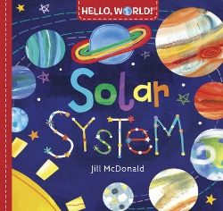  Hello world! Solar system  Jill McDonald | 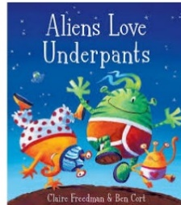  Aliens love underpants  Claire Freedman & Ben Cort | 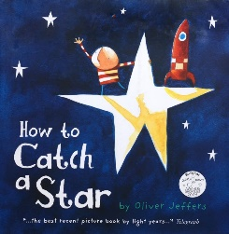  How to catch a star  Oliver Jeffers | 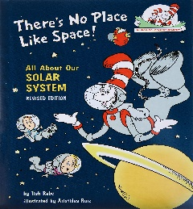  There’s no place like space  Tish Rabe
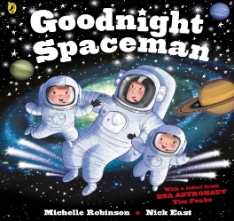  Goodnight spaceman  Michelle Robinson | 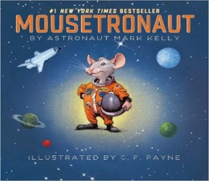  Mousetronaut  Mark Kelly | 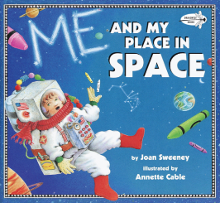  Me and my place in space  Joan Sweeney | 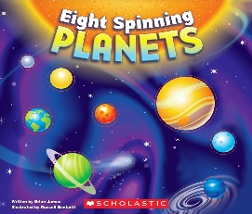  Eight spinning planets  Brian James
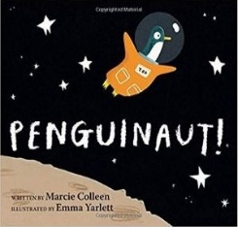  Penguinaut  Marcie Colleen | 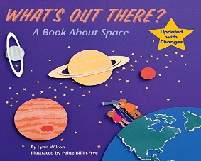  What’s out there?  Lynn Wlison | 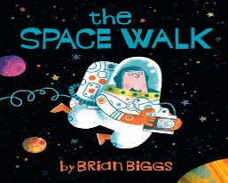  The space walk  Brian Biggs | 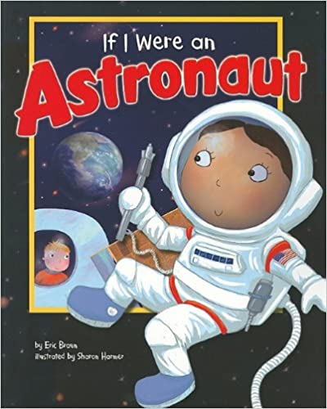  If I were an astronaut  Eric Braun
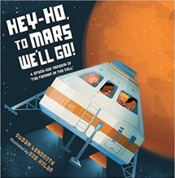  Hey-Ho to Mars we’ll go!  Susan Lendroth | 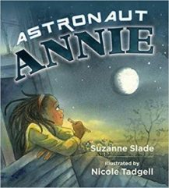  Astronaut Annie  Suzanne Slade | 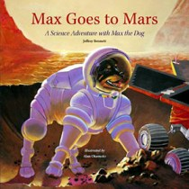  Max goes to Mars  Jeffrey Bennett | 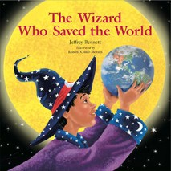  The wizard who saved the world  Jeffrey Bennett
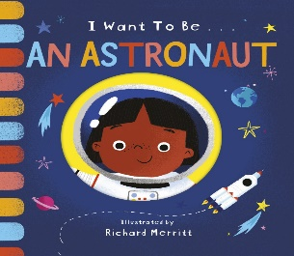  I want to be an astronaut  Becky Davies | 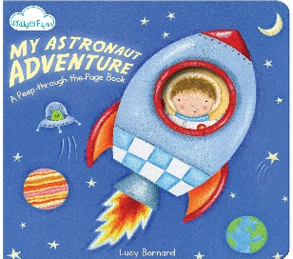  My astronaut adventure  Lucy Barnard | 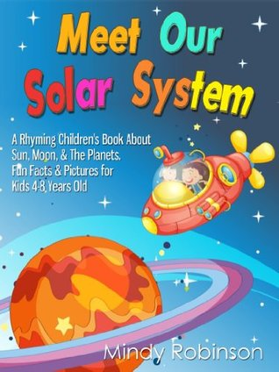  Meet our solar system  Mindy Robinson | 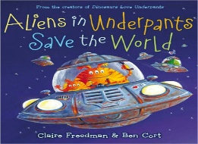  Aliens in underpants save the world  Claire Freedman & Ben Cort
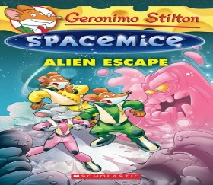  Space mice  Geronimo Stilton | 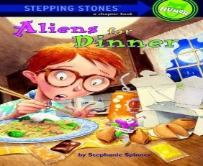  Aliens for dinner  Stephanie Spinner | 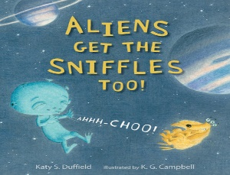  Aliens get the sniffles too!  Katy S. Duffield | 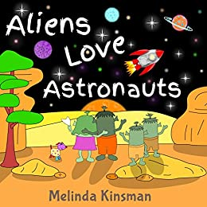  Aliens love astronauts  Melinda Kinsman

